Experiment No: 9
AI-Based Traffic Prediction Using Python (Google Colab)
Aim
To develop and evaluate a simple AI-based traffic prediction system using Python in Google Colab by comparing actual and predicted traffic values over 12 hours and visualizing the prediction performance.
Objective
The objective of this experiment is to simulate traffic data collected over 12 hours and compare actual traffic values with AI-predicted traffic values. The system calculates prediction errors using MAE, MSE, RMSE, and R² score. Graphs are generated to visualize the actual and predicted traffic conditions.
Software Requirements
- Google Colab
- Python 3.x
- NumPy
- Pandas
- Matplotlib
Theory
Traffic prediction systems are used to estimate future traffic conditions and help in efficient traffic management. AI-based models can analyze traffic data and predict traffic levels. In this experiment, actual and predicted traffic values are provided for 12 hours. The prediction performance is evaluated using statistical error measures.
MAE measures the average absolute prediction error.
MSE calculates the average squared prediction error.
RMSE represents the square root of MSE and indicates the average prediction error in the same unit as traffic.
R² score indicates how closely the predicted values follow the actual traffic values.
Algorithm
- Start the program.
- Import NumPy, Pandas, and Matplotlib libraries.
- Create traffic data for 12 hours.
- Store actual and predicted traffic values.
- Calculate prediction error.
- Calculate MAE, MSE, RMSE, and R² score.
- Display the traffic data in a table.
- Plot actual and predicted traffic values.
- Plot the prediction error.
- Display the performance results.
- Stop the program.
Flowchart
START
|
Import Libraries
|
Enter 12-Hour Traffic Data
|
Compare Actual and Predicted Values
|
Calculate Prediction Error
|
Calculate MAE, MSE, RMSE and R²
|
Generate Graphs
|
Display Results
|
END
Program Description
The Python program simulates an AI-based traffic prediction system. Traffic values are considered for 12 hours. Actual traffic values are compared with predicted values generated by the model. The program calculates different performance metrics and generates graphs to visually analyze the prediction accuracy.
Input
- 12-hour traffic data
- Actual traffic values in Mbps
- Predicted traffic values in Mbps
Output
- Traffic prediction table
- MAE
- MSE
- RMSE
- R² score
- Actual vs Predicted Traffic graph
- Prediction Error graph
- Scatter plot
Observations
- Predicted traffic values are close to actual traffic values.
- Smaller MAE and RMSE indicate better prediction accuracy.
- Higher R² indicates better model performance.
- Graphs clearly show the difference between actual and predicted traffic.
Applications
- Smart city traffic management
- Network traffic prediction
- IoT network monitoring
- Communication network planning
- Traffic congestion analysis
Advantages
- Simple and easy to implement.
- Provides quantitative prediction performance.
- Graphical visualization improves understanding.
- Can be extended with real traffic datasets.
- Suitable for Google Colab simulation.
Limitations
- Uses a small simulated dataset.
- Does not use a trained machine learning model.
- Prediction accuracy depends on the given values.
- Real-world traffic contains more complex variations.
Program
# ============================================
# AI-Based Traffic Prediction - 12 Hours
# Google Colab / Python
# ============================================

import numpy as np
import pandas as pd
import matplotlib.pyplot as plt

# Traffic data for 12 hours (Mbps)
hours = np.arange(1, 13)

# Actual traffic values
actual_traffic = [38, 45, 53, 61, 68, 74, 81, 77, 70, 64, 56, 48]

# AI predicted traffic values
predicted_traffic = [40, 43, 55, 59, 70, 72, 79, 80, 68, 66, 54, 50]

# Create DataFrame
data = pd.DataFrame({
"Hour": hours,
"Actual Traffic (Mbps)": actual_traffic,
"Predicted Traffic (Mbps)": predicted_traffic
})

# Calculate prediction error
data["Error (Mbps)"] = (
data["Actual Traffic (Mbps)"] -
data["Predicted Traffic (Mbps)"]
)

data["Absolute Error (Mbps)"] = abs(data["Error (Mbps)"])

# Display data
print("Traffic Prediction Data")
print(data)

# ============================================
# Performance Evaluation
# ============================================

actual = np.array(actual_traffic)
predicted = np.array(predicted_traffic)

# MAE
mae = np.mean(np.abs(actual - predicted))

# MSE
mse = np.mean((actual - predicted) ** 2)

# RMSE
rmse = np.sqrt(mse)

# R2 Score
ss_res = np.sum((actual - predicted) ** 2)
ss_tot = np.sum((actual - np.mean(actual)) ** 2)
r2 = 1 - (ss_res / ss_tot)

print("\nPrediction Performance")
print("-----------------------------")
print("Mean Absolute Error (MAE):", round(mae, 2), "Mbps")
print("Mean Squared Error (MSE):", round(mse, 2))
print("Root Mean Squared Error (RMSE):", round(rmse, 2), "Mbps")
print("R² Score:", round(r2, 3))

# ============================================
# Graph 1: Actual vs Predicted Traffic
# ============================================

plt.figure(figsize=(10, 5))

plt.plot(hours, actual_traffic, marker='o',
label="Actual Traffic")

plt.plot(hours, predicted_traffic, marker='s',
linestyle='--', label="Predicted Traffic")

plt.xlabel("Hour")
plt.ylabel("Traffic (Mbps)")
plt.title("Actual vs Predicted Traffic")
plt.xticks(hours)
plt.grid(True)
plt.legend()

plt.show()

# ============================================
# Graph 2: Prediction Error
# ============================================

plt.figure(figsize=(10, 5))

plt.bar(hours, data["Error (Mbps)"])

plt.axhline(0, linewidth=1)
plt.xlabel("Hour")
plt.ylabel("Prediction Error (Mbps)")
plt.title("Traffic Prediction Error")
plt.xticks(hours)
plt.grid(axis='y')

plt.show()

# ============================================
# Graph 3: Actual vs Predicted Scatter Plot
# ============================================

plt.figure(figsize=(7, 6))

plt.scatter(actual_traffic, predicted_traffic, s=80)

# Ideal prediction line
minimum = min(actual_traffic)
maximum = max(actual_traffic)

plt.plot([minimum, maximum],
[minimum, maximum],
linestyle='--',
label="Ideal Prediction")

plt.xlabel("Actual Traffic (Mbps)")
plt.ylabel("Predicted Traffic (Mbps)")
plt.title("Actual vs Predicted Traffic Scatter Plot")
plt.grid(True)
plt.legend()

plt.show()
Output
Traffic Prediction Data
Hour Actual Traffic (Mbps) Predicted Traffic (Mbps) Error (Mbps) \
0 1 38 40 -2
1 2 45 43 2
2 3 53 55 -2
3 4 61 59 2
4 5 68 70 -2
5 6 74 72 2
6 7 81 79 2
7 8 77 80 -3
8 9 70 68 2
9 10 64 66 -2
10 11 56 54 2
11 12 48 50 -2

Absolute Error (Mbps)
0 2
1 2
2 2
3 2
4 2
5 2
6 2
7 3
8 2
9 2
10 2
11 2

Prediction Performance
-----------------------------
Mean Absolute Error (MAE): 2.08 Mbps
Mean Squared Error (MSE): 4.42
Root Mean Squared Error (RMSE): 2.1 Mbps
R² Score: 0.974
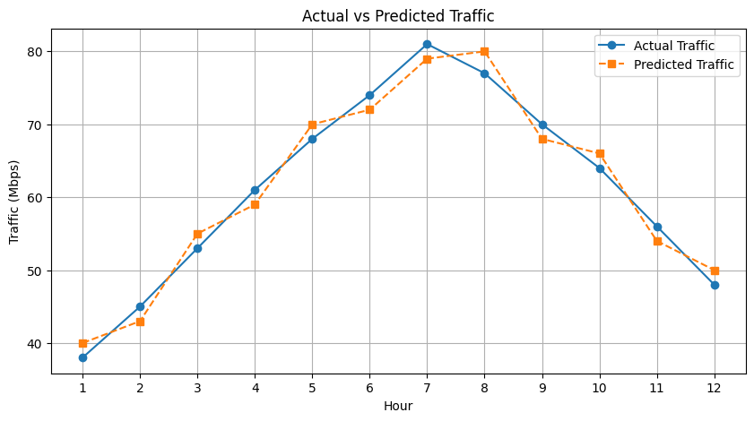
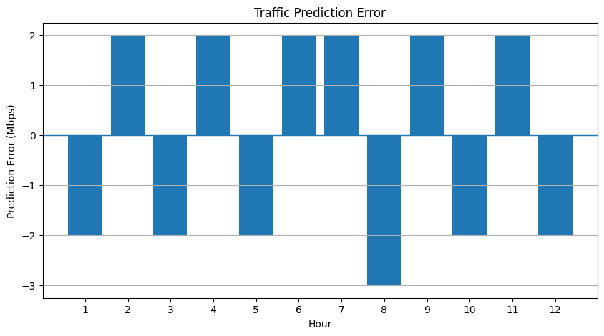
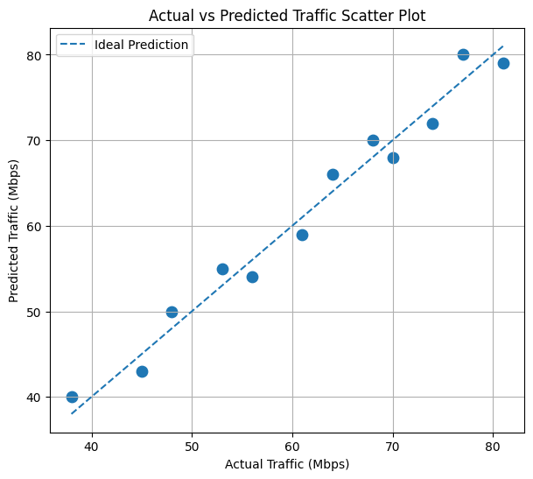

Result
The AI-based traffic prediction system was successfully simulated using Python in Google Colab. The actual and predicted traffic values were compared, prediction errors were calculated, and suitable graphs were generated. The experiment demonstrated how AI-based traffic prediction performance can be evaluated using statistical measures.

